**Step 1: Install VirtualBox on My Windows PC**

1. I went to the official VirtualBox website: <https://www.virtualbox.org/> and clicked on the "Download VirtualBox" button.
2. I selected the version for Macos and downloaded the installer.
3. Once the download was complete, I opened the installer.
4. I followed the installation steps by clicking "Next" through the setup wizard.
5. When prompted, I clicked "Install" and waited for the installation to complete.
6. After installation, I clicked "Finish" to launch VirtualBox.

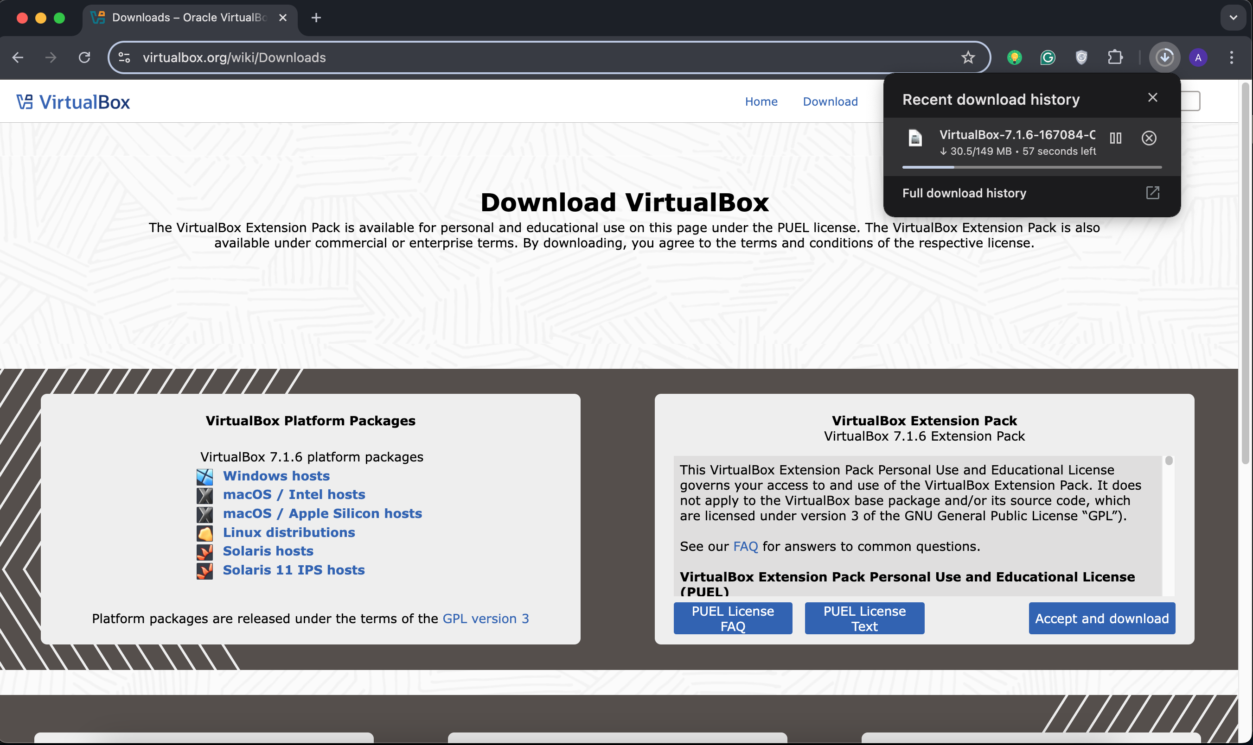

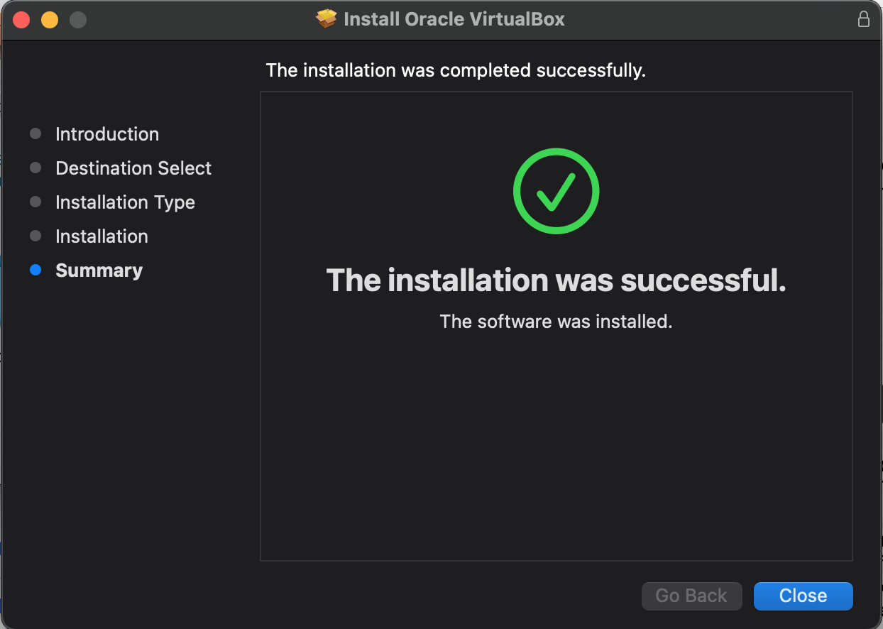

**Step 2: Download Ubuntu**

1. I visited the official Ubuntu website: <https://ubuntu.com/>.
2. I clicked on "Download Ubuntu."
3. I selected the latest LTS (Long-Term Support) version.
4. I downloaded the ISO file to my computer.

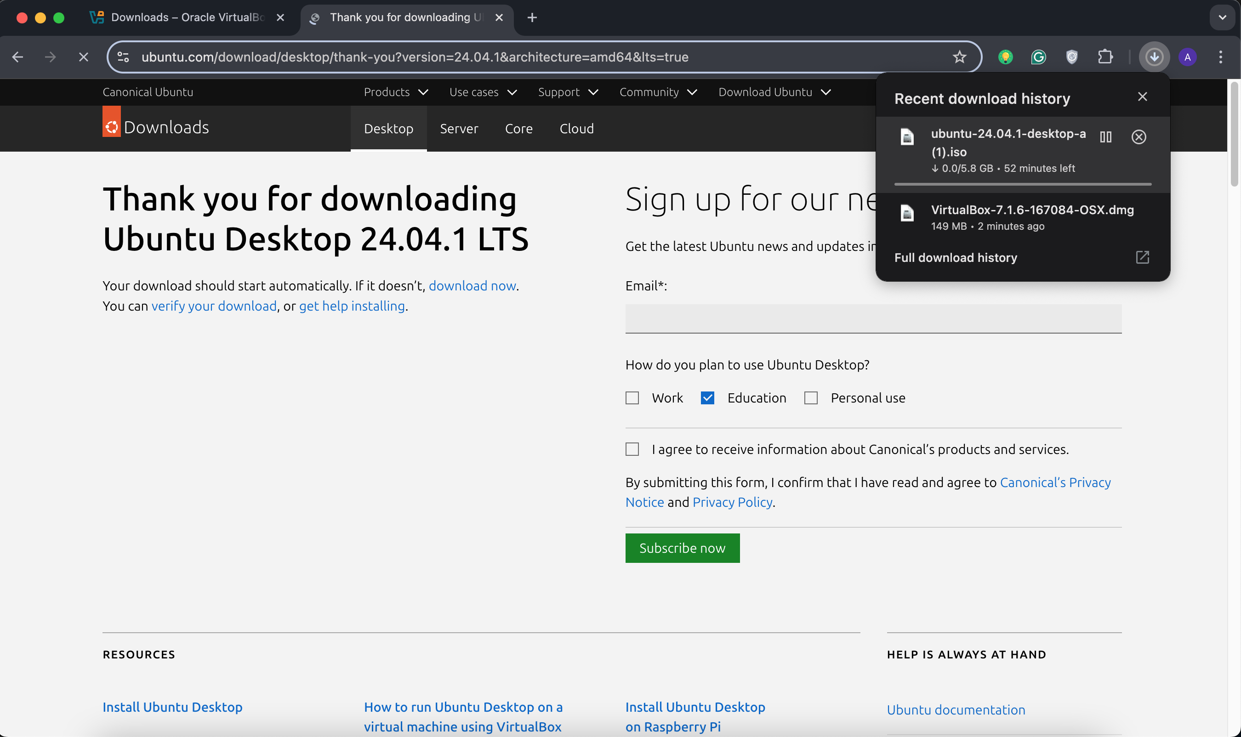

**Step 3: Create a New Virtual Machine in VirtualBox**

1. I opened VirtualBox and clicked on "New" to create a new virtual machine.
2. I named the virtual machine "Ubuntu" and selected "Linux" as the type and "Ubuntu (64-bit)" as the version.
3. I allocated RAM (1024 MB) for better performance and created a new virtual hard disk.
4. I chose "Create a virtual hard disk now" and set 15 GB of storage.
5. I clicked "Finish" to complete the setup.

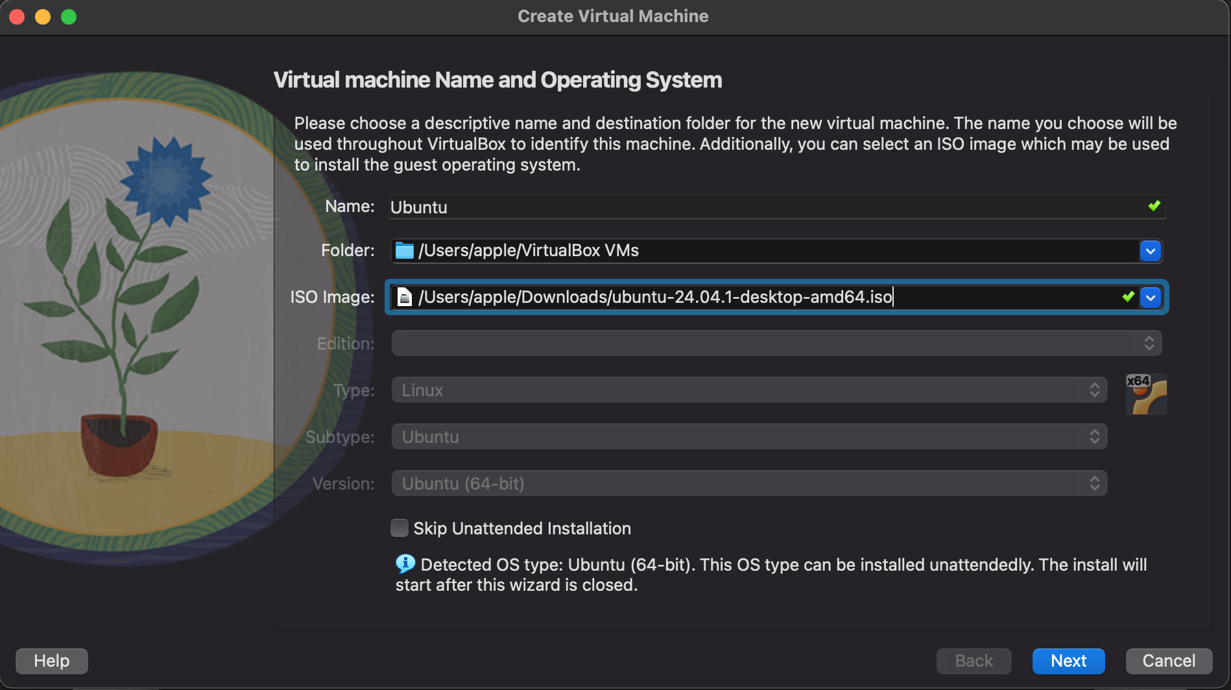

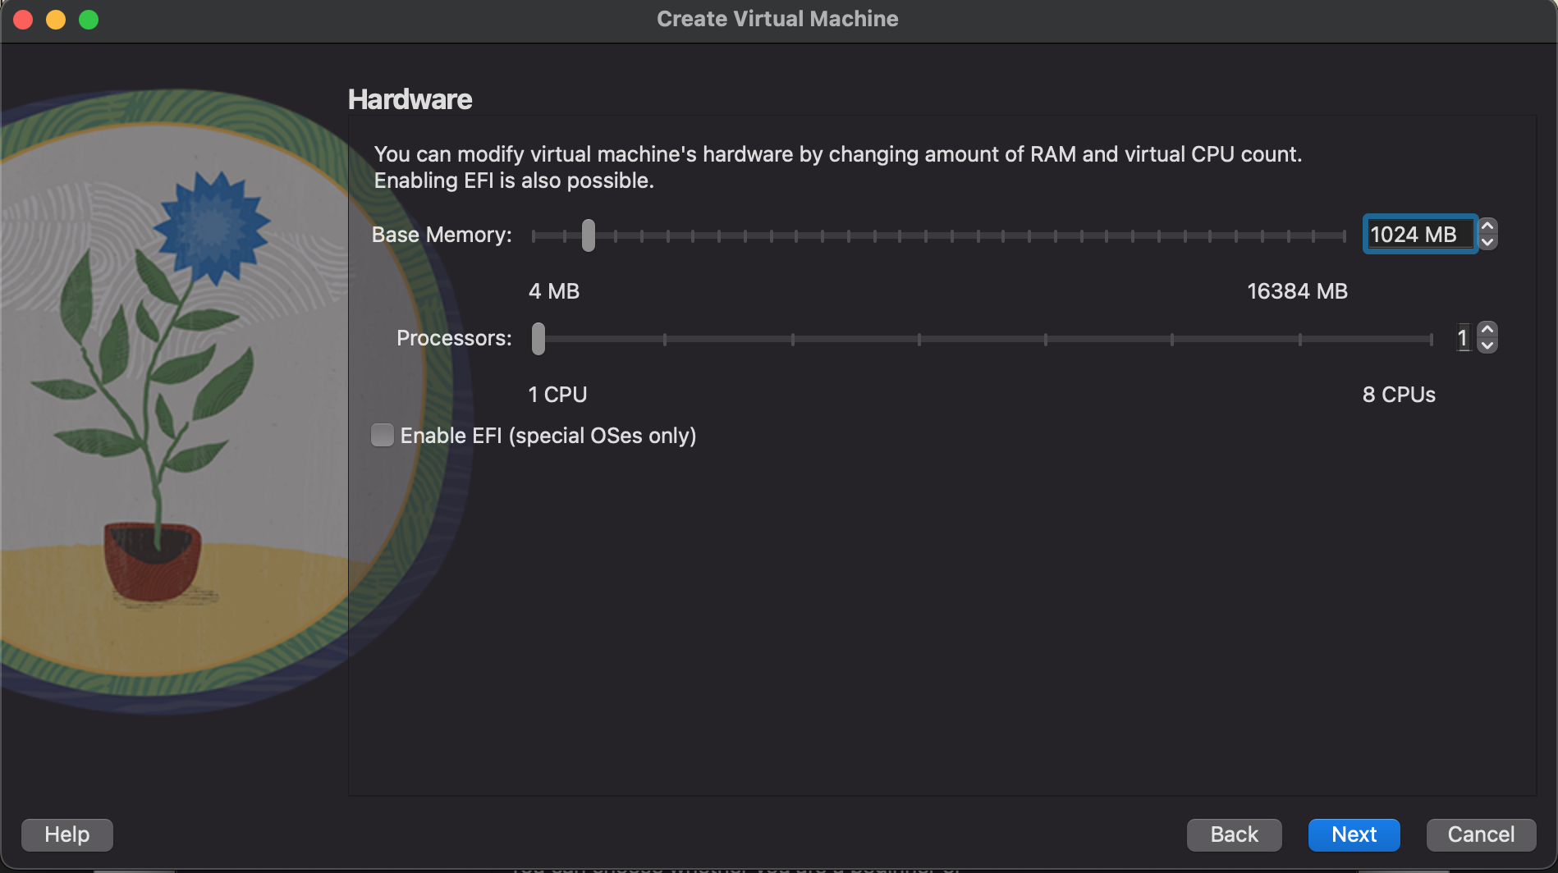

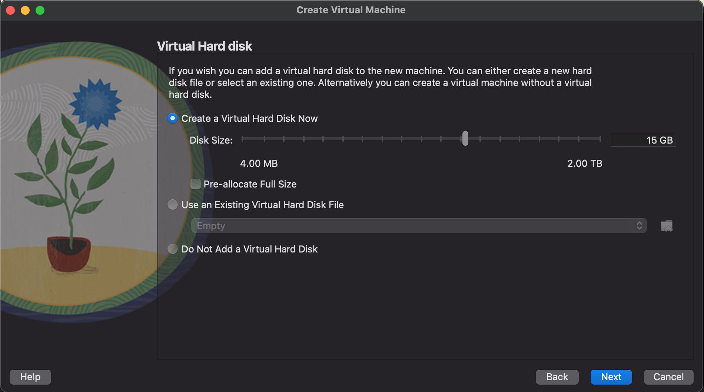

**Step 4: Install Ubuntu on the Virtual Machine**

1. I selected the "Ubuntu" virtual machine and clicked "Start."
2. The Ubuntu installation screen appeared and the installation process took a few minutes to complete.
3. Once done, I was able to log into the VM.

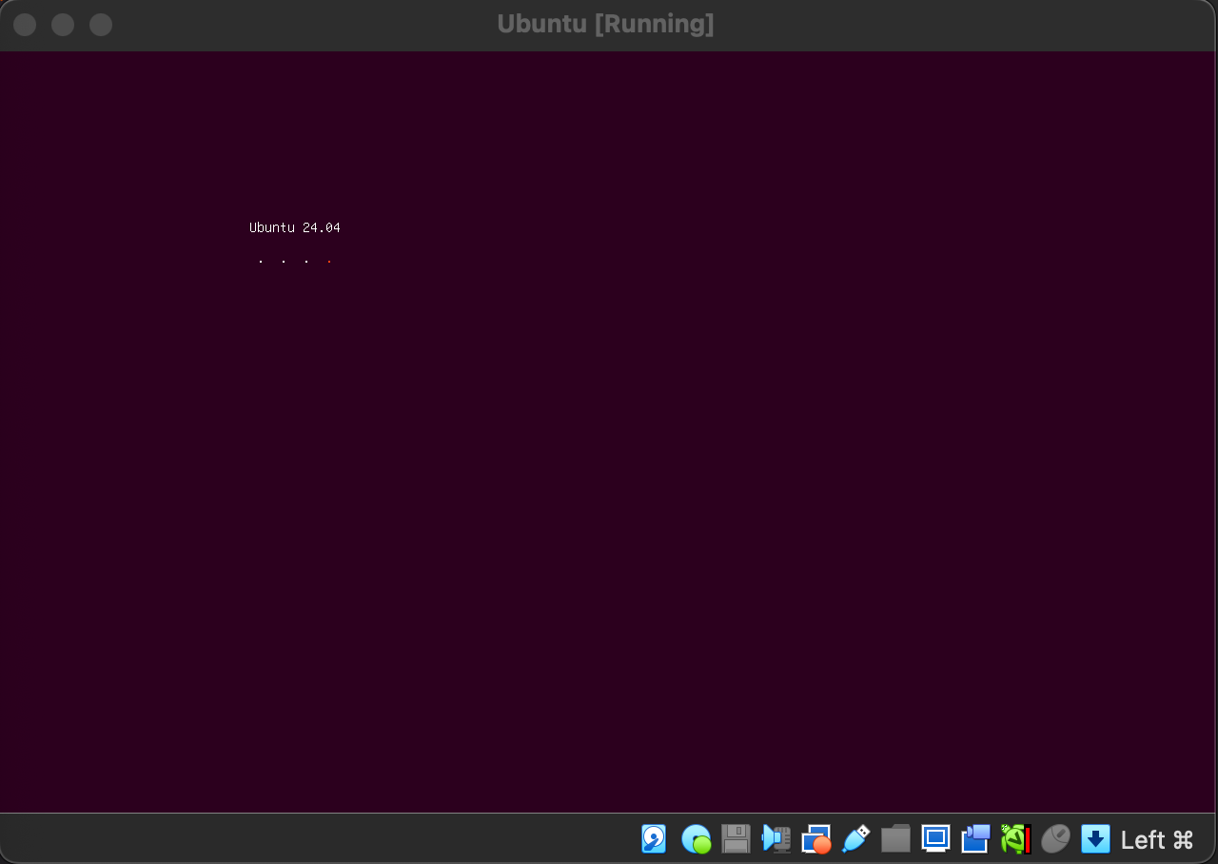

**Step 5: Verify Ubuntu is Running**

1. After restarting, I logged into Ubuntu using my password.
2. I checked that everything was working by opening a few applications.
3. I confirmed that the Ubuntu virtual machine was running inside VirtualBox.

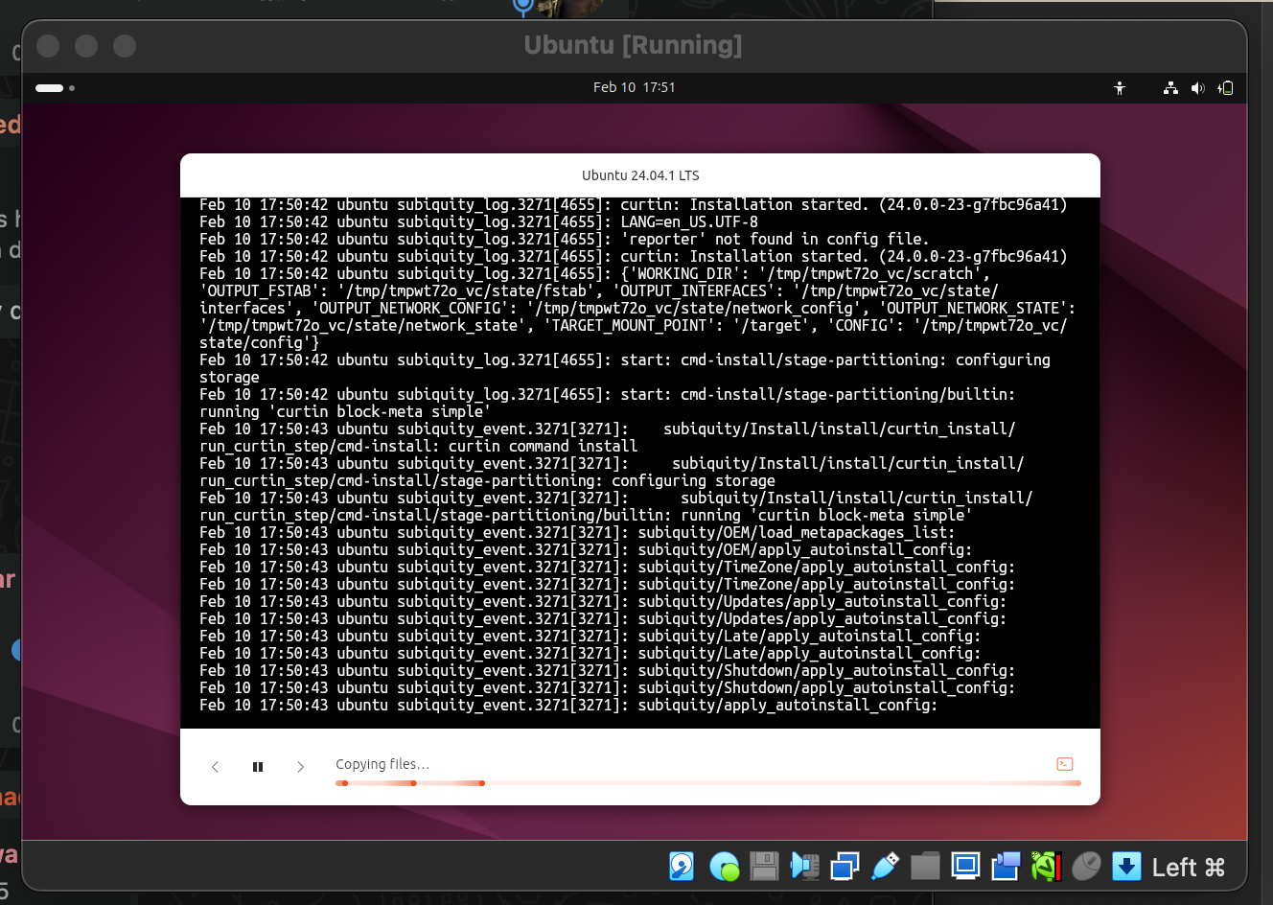

**Conclusion**

I successfully installed VirtualBox and Ubuntu. My Ubuntu virtual machine is fully functional. I followed all the required steps and completed the assignment on time.